Requiremental Analysis

***Data Flow Diagram & User Stories***

|  |  |
| --- | --- |
| Date | 25-06-2025 |
| Team ID | LTVIP2025TMID43697 |
| Project Name | Flight finder: navigating your air travel  options |
| Maximum Marks | 4 Marks |

**Data Flow Diagrams:**

A Data Flow Diagram (DFD) is a traditional visual representation of the information flows within a system. A neat and clear DFD can depict the right amount of the system requirement graphically. It shows how data enters and leaves the system, what changes the information, and where data is stored.

DFD Level 0 :

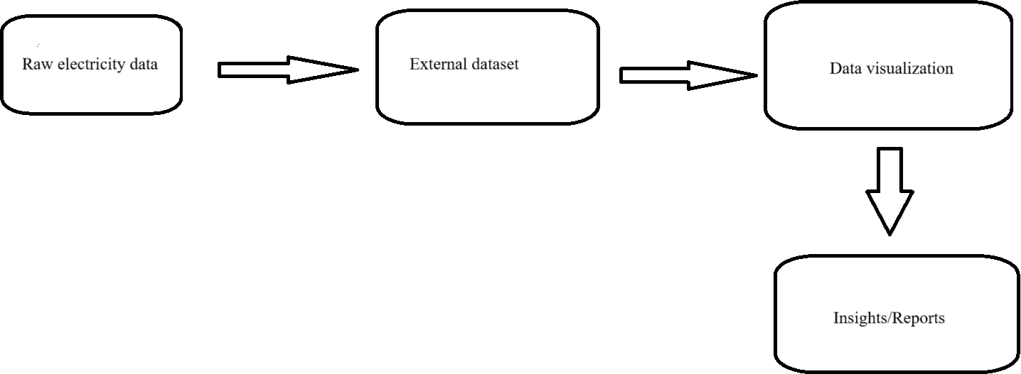

DFD Level 1 (industry level):

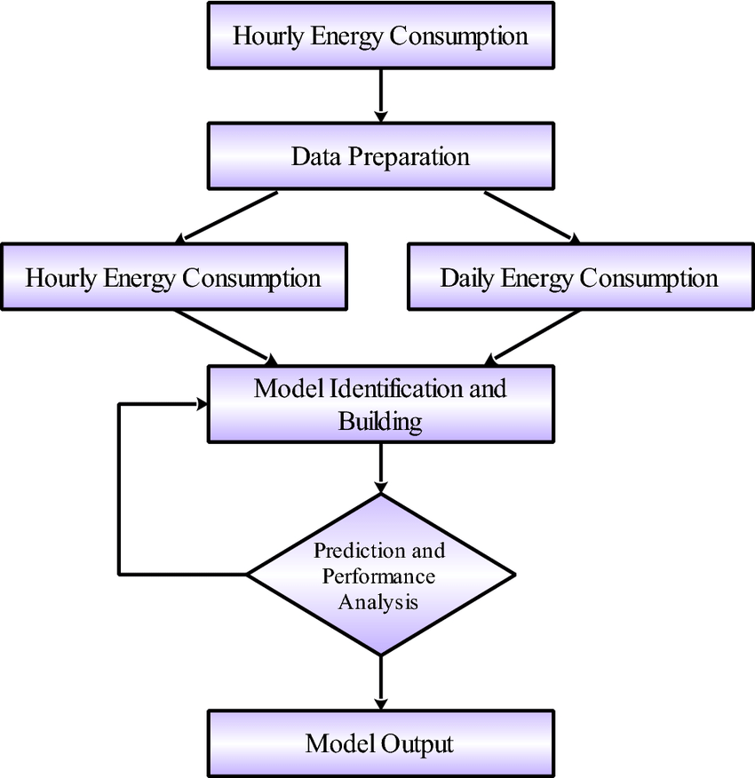

**User Stories:**

|  |  |  |  |  |  |  |
| --- | --- | --- | --- | --- | --- | --- |
| **User Type** | **Functional**  **Requirement (Epic)** | **User Story**  **Number** | **User Story / Task** | **Acceptance Criteria** | **Priority** | **Release** |
| Analyst / Researcher | Dashboard Access & Insights | USN-01 | As a user, I can explore electricity  consumption across sectors and regions using an interactive dashboard. | Able to filter and view data on-demand | High | Sprint- 1 |
| Power Utility Staff | Export & Reporting | USN-02 | As a utility  manager, I can download  consumption  reports filtered by month and region. | Excel/PDF report  available | High | Sprint- 2 |
| Policy Maker | Trend  Forecasting | USN-03 | As a government user, I can identify peak usage trends and plan accordingly. | Visual  trendlines are displayed | Medium | Sprint- 2 |
| Admin | Data Refresh | USN-04 | As an admin, I can upload new data  files to refresh the dashboard. | System reflects updated values | High | Sprint- 1 |
| Public Viewer | Access Summary Insights | USN-05 | As a general user, I can view key  highlights like top- consuming sectors. | Summary cards/charts available | Medium | Sprint- 1 |